**User’s Manual**



i

**USER'S MANUAL**

**TABLE OF CONTENTS**

Page #

* 1. [***GENERAL INFORMATION***](#1.0 GENERAL INFORMATION) ***1-2***
  2. [**System Overview**](#1.1_System Overview) **2-2**
  3. **[Organization of the Manual](#1.2_Organization of the Manual)** **2-2**
  4. ***[SYSTEM SUMMARY](#2.0 SYSTEM SUMMARY)*** ***3-4***
  5. **[System Configuration](#2.1_System Configuration)** **4-4**
  6. **[User Access Levels](#2.2_User Access Levels)** **4-4**
  7. **Contingencies** **4-4**
  8. ***[GETTING STARTED](#3.0 GETTING STARTED)*** ***5-12***
  9. **[Installation and Logging In](#3.1_Installation and Logging In)** **6-6**
  10. **System Features**  **6-11**
      1. Login 6-6
      2. Dashboard 7-7
      3. My Account 7-7
      4. Client List 8-8
      5. Insurances 8-8
      6. Categories List 9-9
      7. Policies List 9-9
      8. Date-wise Transactions 10-10
      9. Settings and User List 10-11

3.2.9a Settings 10-10

3.2.9b User List 11-11

* 1. **Updating****Personal Information** **11-12**
  2. **[Exit System](#3.4_Exit System)** **12-12**

1. ***[USING THE SYSTEM](#4.0 USING THE SYSTEM)*** ***13-24***

4.1 Categories Management 14-16

4.2 Insurance Policy Management 16-17

4.3 Client Management 17-19

4.4 Vehicle Insurance Management 19-21

4.5 Special Instructions for Administrators 21-24

4.5.1 Manage User List 21-23

4.5.2 Manage System Information 23-24

* 1. ***[REPORTING](#5.0 REPORTING)*** ***25-27***
  2. **Generating a Report**  **26-26**
  3. **Printing a Report** **26-27**

**1.0 GENERAL INFORMATION**

* 1. **GENERAL INFORMATION**

General Information section explains in general terms the system and the purpose for which it is intended.

# System Overview

The Liberty Finance System is a web-based application, which allows the user to store the client-insured vehicle details easily. It helps the business system be more effective, efficient, and easy to retrieve data. The system requires the management to populate the list of vehicle categories and insurance policies for the first time of using the system. Clients Information is also stored in the system it has a feature that lists the clients' insured vehicles. The application saves information collected to the database. It also has user-friendly features and functionalities. The System also generates a printable and date-wise transaction report.

# Organization of the Manual

The user’s manual consists of five sections: General Information, System Summary, Getting Started, Using the System, and Reporting.

**General Information** section explains in general terms the system and the purpose for which it is intended.

**System Summary** section provides a general overview of the system. The summary outlines the uses of the system’s hardware and software requirements, system’s configuration, user access levels and system’s behaviour in case of any contingencies.

**Getting Started** section explains how to get Liberty Finance System and Login to your device. The section presents briefly system features.

**Using the System** section provides a detailed description of system functions.

**Reporting** section describes in what way information collected by the application are presented and how to access the information.

**2.0 SYSTEM SUMMARY**

* 1. **SYSTEM SUMMARY**

System Summary section provides a general overview of the system. The summary outlines the uses of the system’s hardware and software requirements, system’s configuration, user access levels and system’s behaviour in case of any contingencies.

# System Configuration

Liberty Finance System operates on a web browsers (recommended Chrome or Firefox) on any Computer. The application requires connection to Internet in order to run through the web browser. Once the system is online a user can add new information, modify existing information, or delete unneeded information.

# User Access Levels

The Liberty Finance System is accessible only for the company's staff. The system requires the users to log their system credentials in order to gain access to the features and functionalities of the said system. The system can only be accessed by two different user roles which are the **Administrator** and **Staff**. The Administrator users are ones who have the privilege to access and manage all the features and data in the system while the Staff has only a limited.

# Contingencies

In case of power outage data are not saved in internal memory of the operating device. In case there is no Internet connection available data cannot be saved in internal memory of the operating device.

**3.0 GETTING STARTED**

* 1. **GETTING STARTED**

Getting Started section explains how to get Liberty Finance System and Login to your device. The section presents briefly system menu.

# Installation and Logging In

The system requires a web browser to be installed in a computer to access the system using the URL: . The login page will appear, then the administrator must enter a username and a password to login. After logging in he/she will be able to create new users.

# System Features

The Liberty Finance System consists of different features which are found in different pages within the system. The system has the Login page, Dashboard, My Account, Client List, Insurances, Categories List, Policies List, Date-wise Transactions, and Settings. Figure 1 – 9 illustrates the view of these pages with their features.

**3.2.1** **Login:** the users are able to enter their login credentials i.e. **Username** and **Password.**

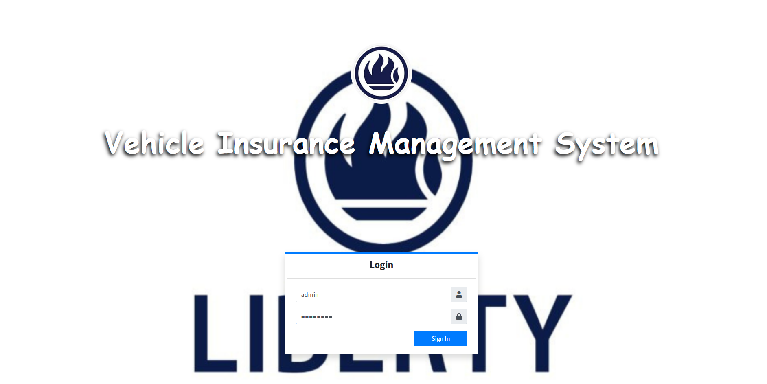

**Figure 1. The Login page**

**3.2.2 Dashboard:** the user can view a displayed summary list of client information.

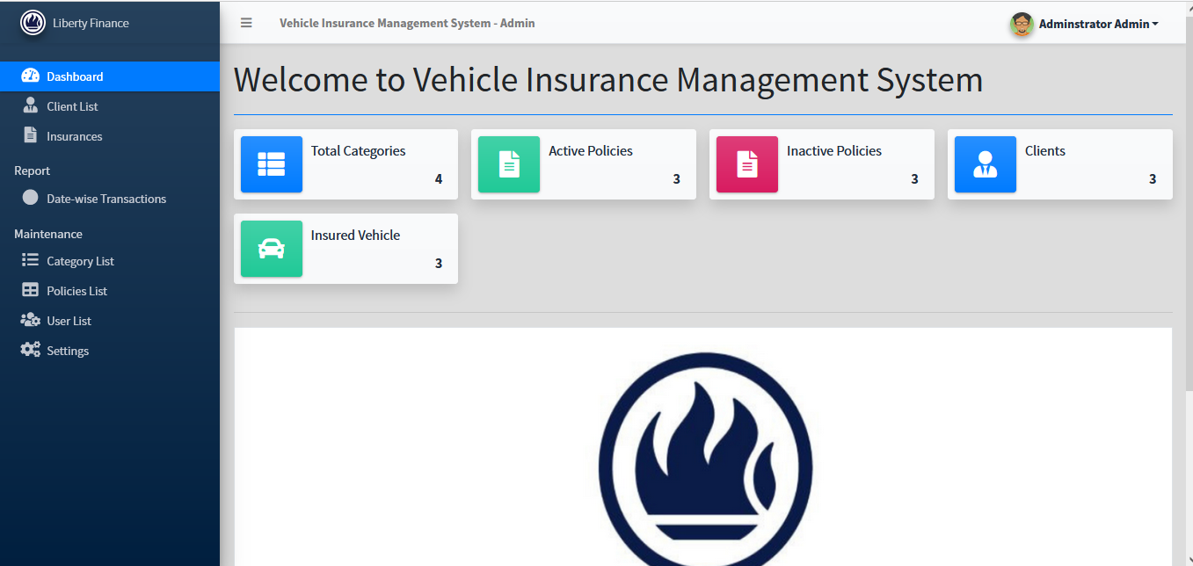

**Figure 2. Dashboard**

**3.2.3 My Account:** the users are able to view and update their profile.

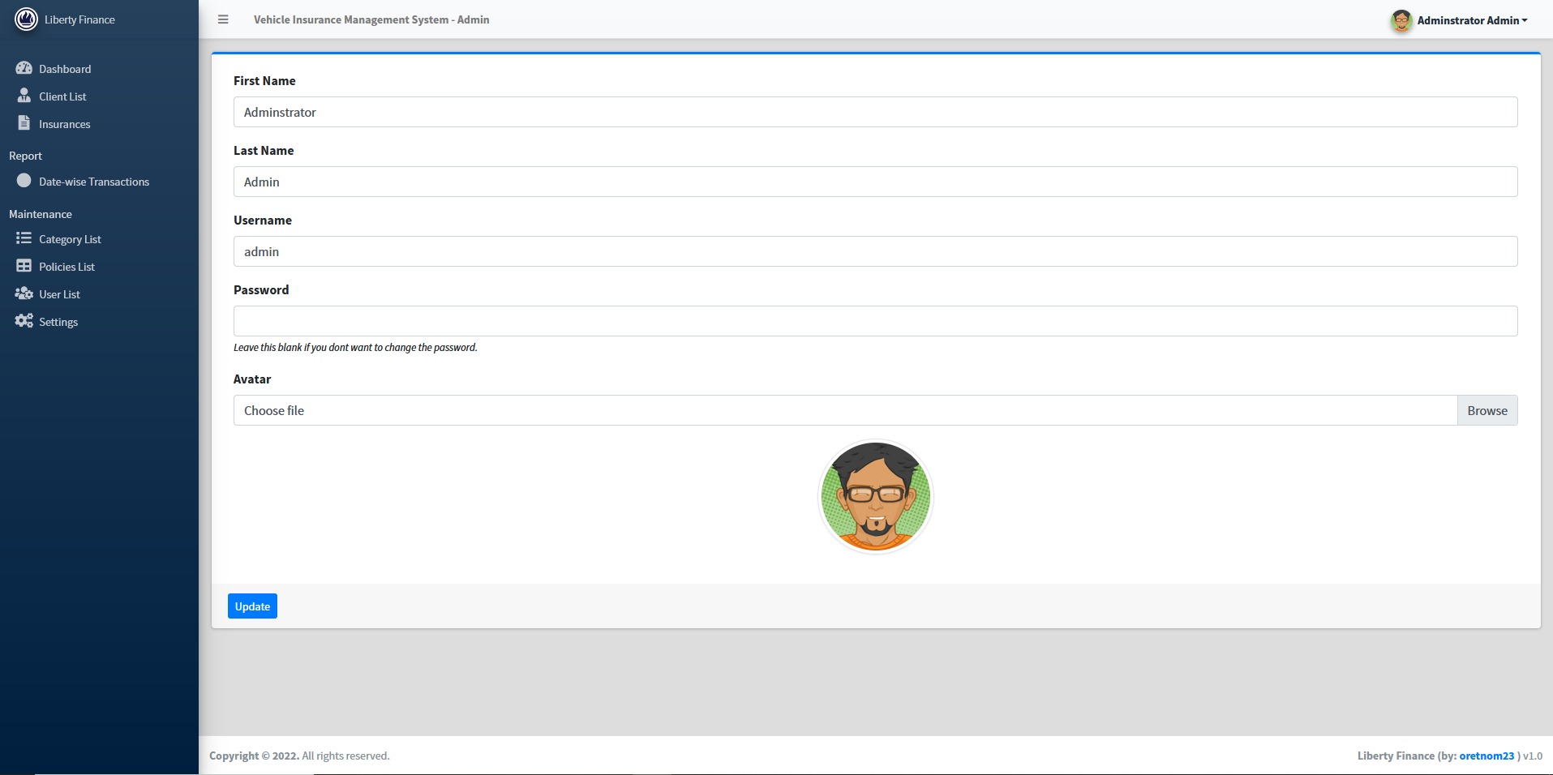

**Figure 3. My Account**

**3.2.4 Client List:** the user is able to view, add, edit or delete client information.

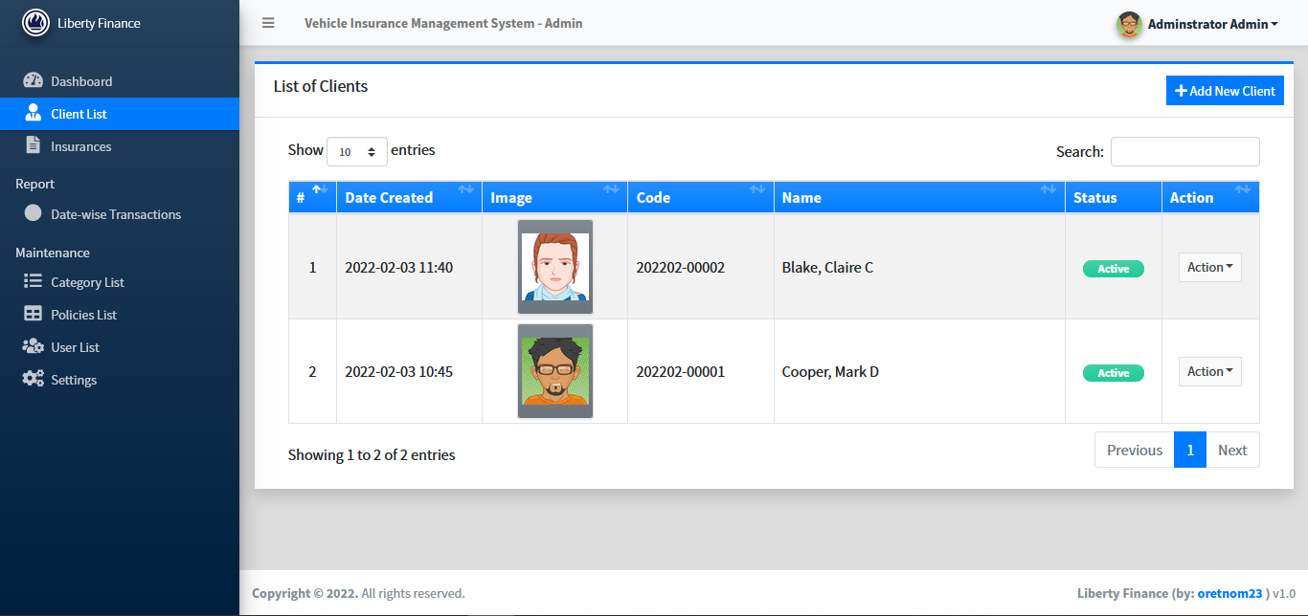

**Figure 4. Client List**

**3.2.5 Insurances:** the user is able to view, add, edit or delete insurance information.

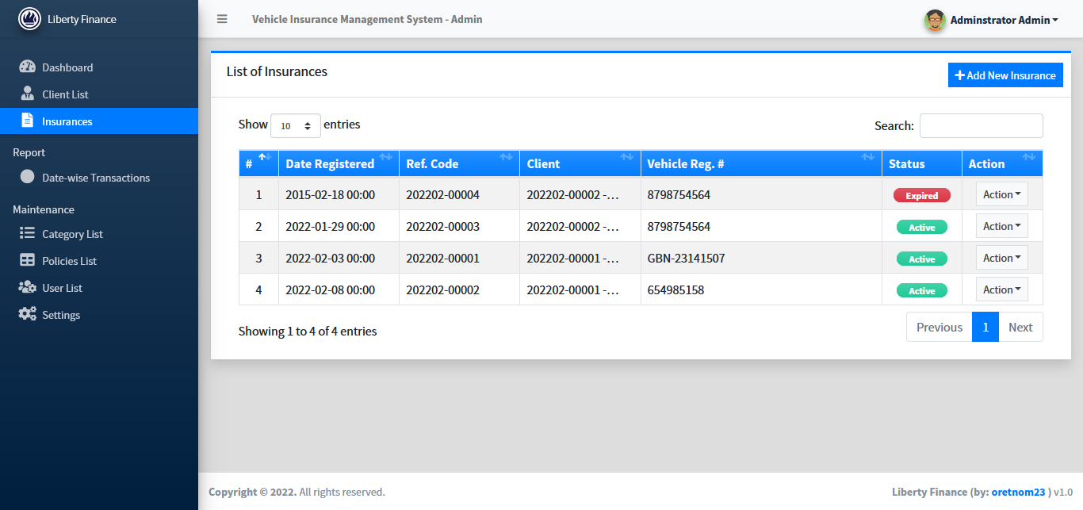

**Figure 5. Insurances**

**3.2.6 Categories List:** the user is able to view, add, edit or delete categories.

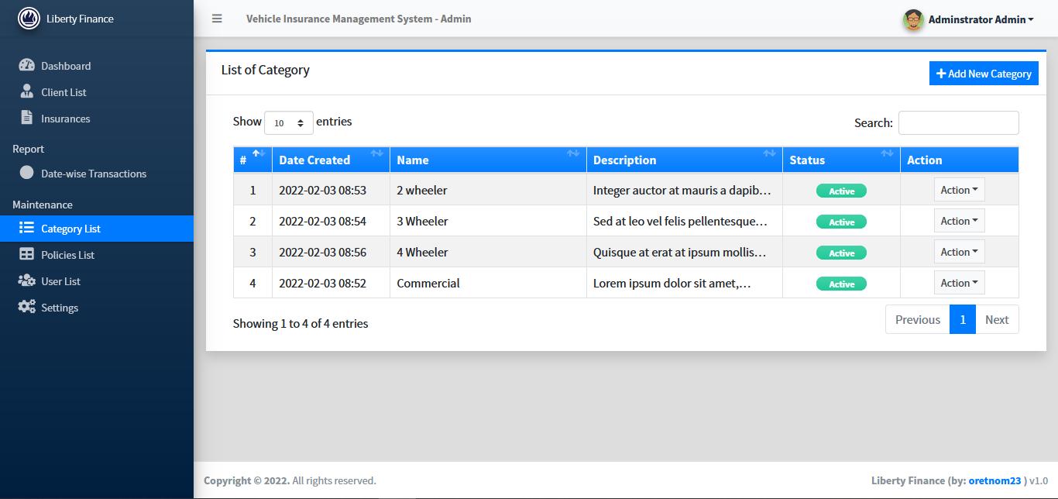

**Figure 6. Categories**

**3.2.7 Policies List:** the user is able to view, add, edit or delete policies.

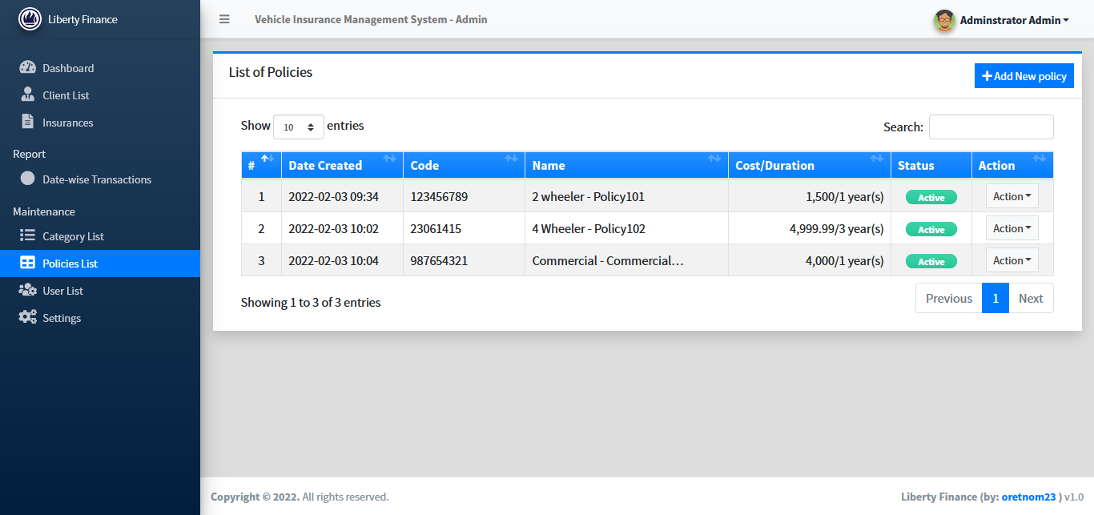

**Figure 7. Policies List**

**3.2.8 Date-wise Transactions:** the user can generate a report from the system and print it out.

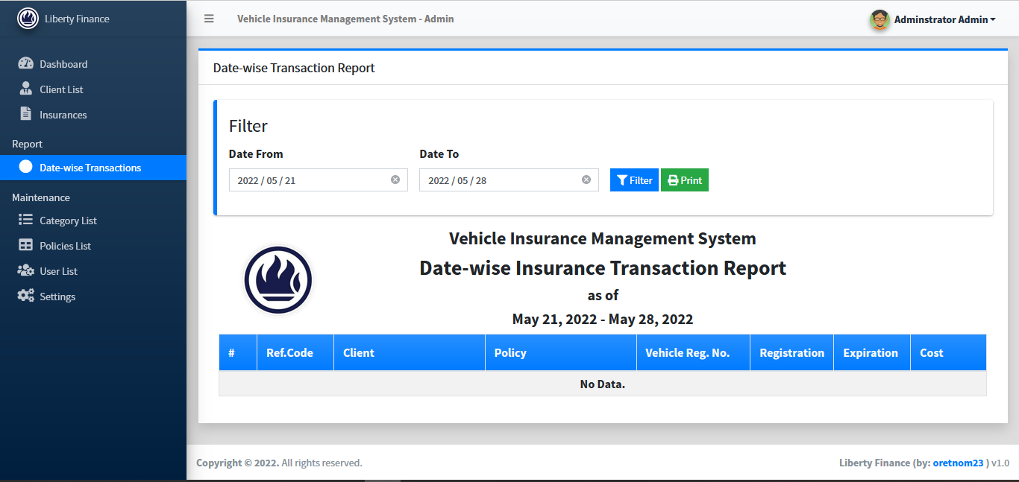

**Figure 8. Date-wise Transactions**

**3.2.9 Settings and User List:** Only an administrator can be able to use these features.

**3.2.9a Settings:** an administrator can update information about the system.

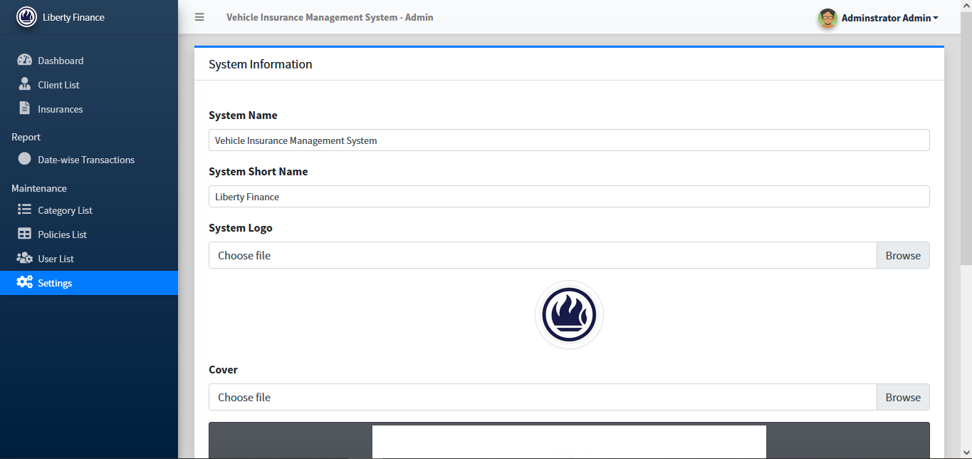

**Figure 9a. Settings**

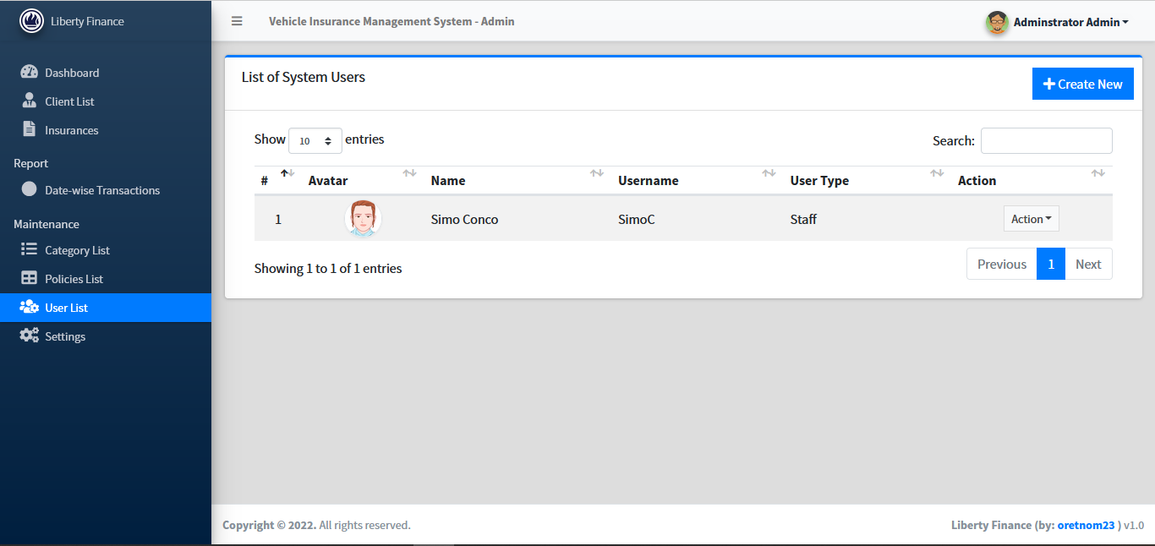**3.2.9b User List:** an administrator is able to view, add, edit or delete policies.

**Figure 9b. User List**

# Updating Personal Information

Users have a right to change their Username and Password anytime. The user can update their personal information by opening the “**My Account**” feature which is located in a drop-down list at the **right-top** corner after logging in to the system. See the illustration on **Figure 10a.**

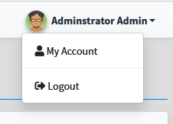 **Figure 10a.** Press on My Account.

After opening the “My Account” window the user can change his/her First Name, Last Name, Username, Password, and upload his/her picture, then press the update botton to save the new information. See illustration on **Figure 10b** and **10c**.

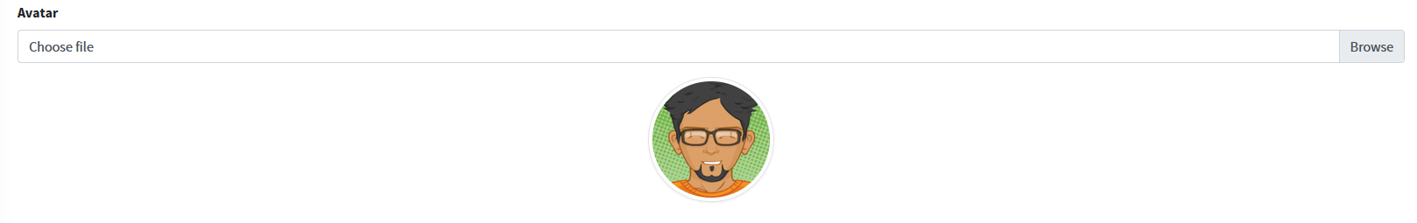

**Figure 10b.** Press on Browse to upload a picture.

 **Figure 10c.** Press on Update to save the new information

# Exit System

The user can exit the system by using the “**Logout”** feature which is also located in a drop-down list at the **right-top** corner after logging in to the system. See the illustration on **Figure 11.**

.

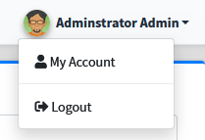 **Figure 11.** Press on Logout to exit the system.

**4.0 USING THE SYSTEM**

**4.0 USING THE SYSTEM**

This section provides a detailed description of system functions.

## 

## 4.1 Categories Management

The Administrator is the only one who can add, edit, and delete in the category list shown on **Figure 6**. The staff members will only be able to view the list.

**4.1.1 Add New Category**

The admin must use the “**Add New Category**” feature to add a new category on the system. Shown on **figure 12a**.

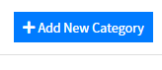

**figure 12a.** Press the “Add New Category” button to add a new category.

After pressing the button a form should appear. The user will be able to enter the Category Name, Description and Status. The information entered will be saved to the list by using the **Save** button. Illustration shown on **figure 12b**.

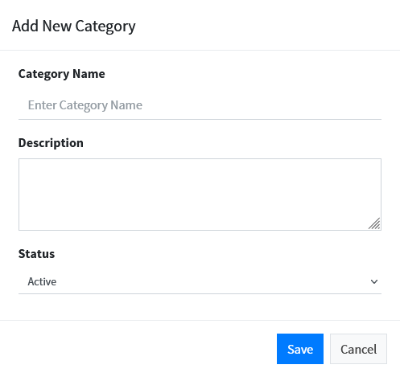

**figure 12b.** Press the **“Save”** button to save a new category.

**4.1.2 Edit Category**

To change information on an existing category a user must use the “**Edit**” feature which is found in a drop-down list **(Action)** located at the right-side of the Category list, see **Figure 6**. **Figure 12c** shows the drop-down list.

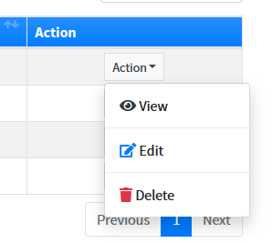**Figure 12c.** Press on “**edit**” to change information.

The form on **figure 12b** will appear then the user change the information. After making all the changes, press the “**Save**” button.

**4.1.3 View Category**

To view category information the user must press “**View**” from the drop-down list shown on **figure 12c.** press **close** once you’re done viewing.

**4.1.4 Delete Category**

To delete a category from the list the user must press “**Delete**” from the drop-down list shown on **figure 12c.**

Press **continue** to remove the category from the list.

**4.1.5 Search Category**

To search for a category on the list the user must use the **“Search:”** feature located at **top-right corner** above the list. **Figure 12d** shows the “Search:”feature.

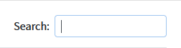

**Figure 12d.** Enter the category name, date created, or description to search for a category.

**4.1.6** **Previous/Next Category List**

* To view the previous category list, the user must use the “**Previous**” feature located on the **bottom-right corner** below the list.
* To view the next category list, the user must use the “**Next**” feature located on the **bottom-right corner** below the list.

## 

## 4.2 Insurance Policy Management

The administrator is the only one who can add, edit, and delete insurance policies shown on **Figure 7**. The staff members can view the existing policies.

**4.2.1 Add New Policy**

The admin must use the “**Add New Policy**” feature to add a new policy on the system. Shown on **figure 13a.**



**Figure 13a.** Press the “Add New policy” button to add new policy.

The form on **figure 13b** should appear where you fill in the policy details and press **Save** to save the information to the list.

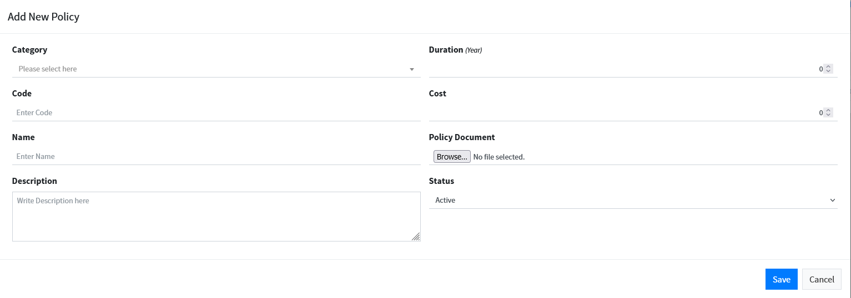

**Figure 13b.** Fill the policy details and press **Save.**

Press **Cancel** to close the form without saving the information.

Press “Browse…” to upload the policy document. See **Figure 13c.**

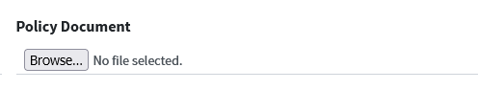

**Figure 13c.**

**4.2.2 Edit Policy**

To change information on an existing policy a user must use the “**Edit**” feature which is found on a drop-down list **(Action)** located at the right-side of the policy list. See **Figure 12c.**

**4.2.3 View Policy**

To view policy information the user must press “**View**” from the drop-down list shown on **figure 12c.**

**4.2.4 Delete Policy**

To delete a policy from the list the user must press “**Delete”** from the drop-down list shown on **figure 12c.**

**4.2.5 Search Policy**

To search for a policy on the list the user must use the “**Search**” feature located at the **top-right corner** above the list. See **Figure 13d.**

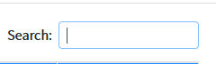

**Figure 13d.** Enter the policy code, name, or date created to search for a policy.

**4.2.6** **Previous/Next Policies List**

* To view the previous Policies list, the user must use the “**Previous**” feature located on the **bottom-right corner** below the list.
* To view the next Policies list, the user must use the “**Next**” feature located on the **bottom-right corner** below the list.

## 4.3 Client Management

The administrator is the only one who can add clients on the client list shown on **Figure 4**. The staff members can view, edit, and delete the existing clients.

**4.3.1 Add New Client**

The admin must use the “**Add New Client**” feature to add a new client. See **figure 14a.**



**Figure 14a.** Press the “Add New Client” button to add a new client.

After pressing the button you should see the form on **figure 14b.** Enter the client details and press **Save** to save the information or press **Cancel** to close the form without saving the information. Use the “Browse…” feature to upload the client’s picture.

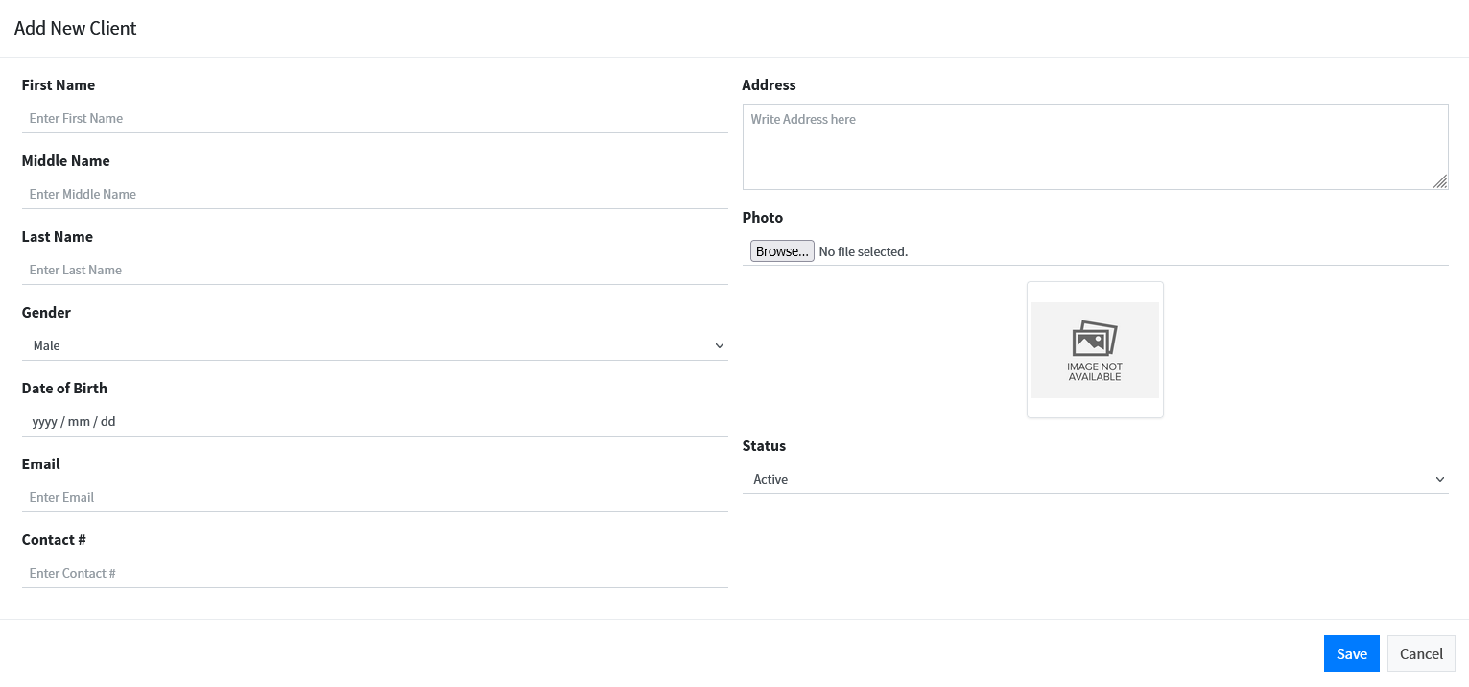

**Figure 14b.**  Fill the client details and press **Save.**

**4.3.2 Edit Client Information**

To change information on an existing client a user must use the “**Edit**” feature which is found on a drop-down list **(Action)** located at the right-side of the policy list. See **Figure 12c.**

**4.3.3 View Client Information**

To view client information the user must press “**View**” from the drop-down list shown on **figure 12c.**

**4.3.4 Delete Client Information**

To delete a client from the list the user must press “**Delete”** from the drop-down list shown on **figure 12c.**

**4.3.5 Search Client**

To search for a client on the list the user must use the “**Search**” feature located at the **top-right corner** above the list. See **Figure 14c.**

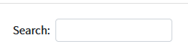

**Figure 14c.** Enter a client code, name, or date created to search for a client.

**4.3.6** **Previous/Next Clients List**

* To view the previous Clients list, the user must use the “**Previous**” feature located on the **bottom-right corner** below the list.
* To view the next Clients list, the user must use the “**Next**” feature located on the **bottom-right corner** below the list.

## 4.4 Vehicle Insurance Management

The administrator is the only one who can add vehicle insurances on the insurance list shown on **Figure 5**. The staff members can view, edit, and delete the existing information.

**4.4.1 Add New Insurance**

The admin must use the “**Add New Category**” feature to add a new category on the system. See illustration on **figure 15a.**



**Figure 15a.** Press the “Add New Insurance” button to add a new vehicle insurance.

After pressing the button you should see the form on **figure 15b.** Enter the vehicle insurance details and press **Save** to save the information or press **Cancel** to close the form without saving the information.

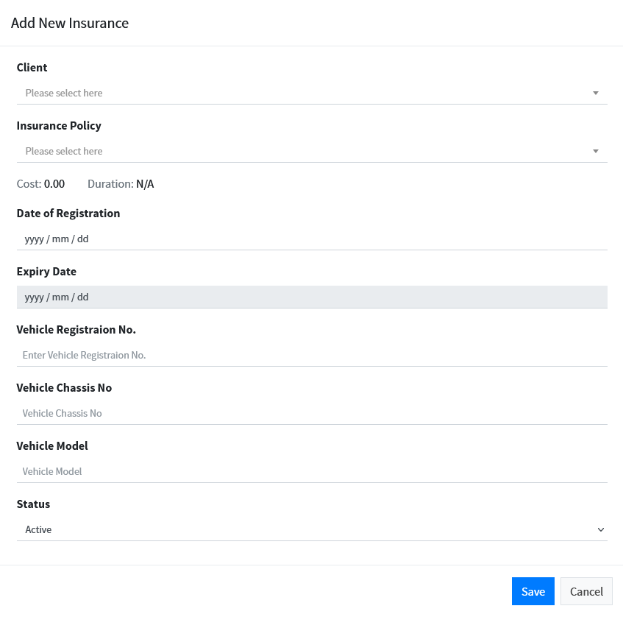

**Figure 15b.** Fill the vehicle Insurance information and press **Save.**

**4.3.2 Edit Insurance Information**

To change information on an existing vehicle insurance a user must use the “**Edit**” feature which is found on a drop-down list **(Action)** located at the right-side of the policy list. See **Figure 12c.**

**4.3.3 View Insurance Information**

To view client information the user must press “**View**” from the drop-down list shown on **figure 12c.**

**4.3.4 Delete Insurance Information**

To delete vehicle insurance from the list the user must press “**Delete”** from the drop-down list shown on **figure 12c.**

**4.3.5 Search Vehicle Insurance**

To search for vehicle insurance on the list the user must use the “**Search**” feature located at the **top-right corner** above the list. See **Figure 15c.**



**Figure 15c.** Enter a Vehicle Reg. #, client name, or date registered to search for vehicle insurance.

* + 1. **Previous/Next Insurance List**
* To view the previous Insurance list, the user must use the “**Previous**” feature located on the **bottom-right corner** below the list.
* To view the next Insurance list, the user must use the “Next” feature located on the bottom-right corner below the list.

# 

# 4.5 Special Instructions for Administrators

These instructions only apply to Administrators.

**4.5.1 Manage User List**

The admin have the privilege to manage the user list shown on **Figure 9b,** by using different features to perform tasks such as adding new users, editing existing user’s information, or delete users from the system.

**4.5.1a. Add New User**

The admin can add a new user by using the “**Create New**” button located on the top-right corner above the users list. See the illustration on **figure 16a.**

 **figure 16a.** press “**Create New**” to add a new user.

After pressing the button you should see the form on **figure 16b.** Enter the user information and press **Save** to save the information or press **Cancel** to close the form without saving the information.

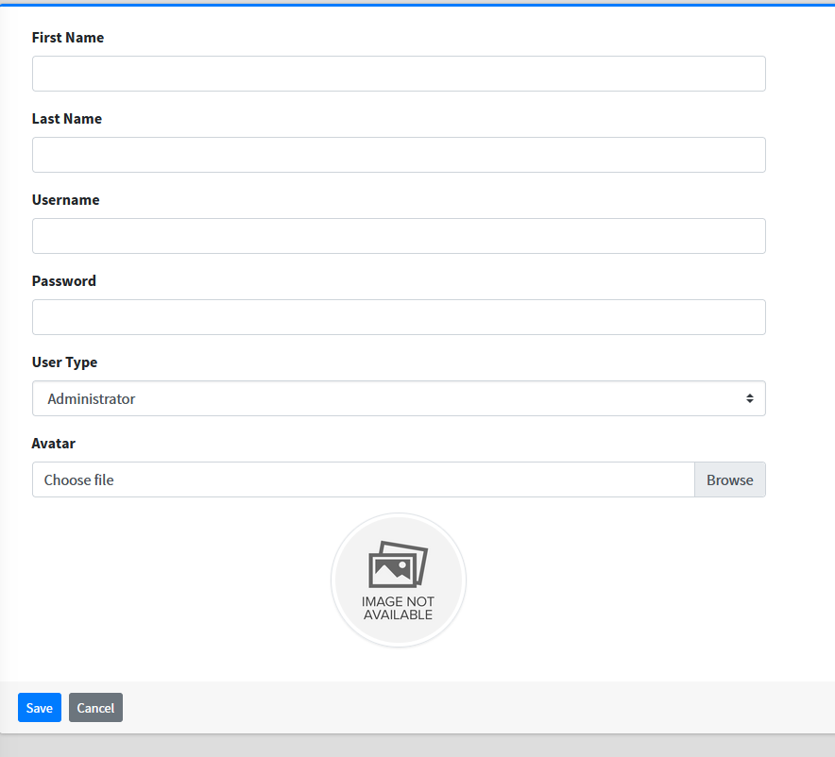

**Figure 16b.** Enter user information and press **Save.**

**4.5.1b. Edit User Information**

To change information on an existing user the admin must use the “**Edit**” feature which is found on a drop-down list **(Action)** located at the right-side of the policy list. See **Figure 12c.**

**4.5.1c. View User Information**

To view User information the admin must press “**View**” from the drop-down list shown on **figure 12c.**

**4.5.1d. Delete User Information**

To delete a User from the list the admin must press “**Delete”** from the drop-down list shown on **figure 12c**

**4.5.1e. Search User**

To search for a client on the list the user must use the “**Search**” feature located at the **top-right corner** above the list. See **Figure 16c.**



**Figure 16c.** Enter a user’s name to search for a user.

**4.5.2 Manage System Information**

The admin can update the system information such as the system name, system cover picture, system logo and system short name as illustrated on **figure 9a**.

**4.5.2a. Uploading System logo**

The admin must use the “**Browse**” feature to select the logo. See **figure 17a.**

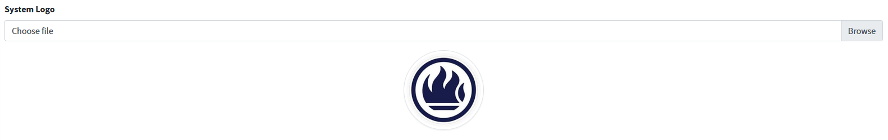

**Figure 17a.** Press “**Browse”**  to select a logo.

**4.5.2b. Uploading Cover**

The admin can upload the system cover by using the “**Browse”** feature and select the picture. See **figure 17b.**

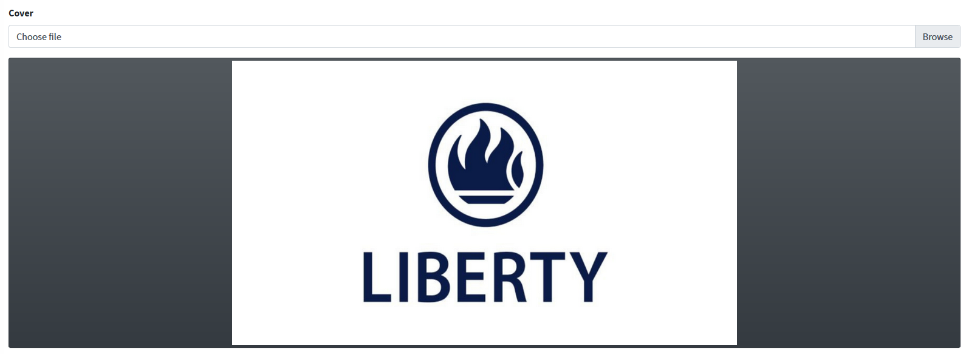

**Figure 17b.** Press “**Browse”** to select a picture.

**4.5.2c. Saving Information**

After making changes the “**Update**” button must be used to save the new information. See **figure 17c**.



**figure 17c.** press “**Update**” the save information.

**5.0 REPORTING**

* 1. **REPORTING**

Reporting section describes in what way information collected by the application are presented and how to access the information.

# Generating a Report

The user is able to generate reports by using the “**Filter**” feature to filter information recorded between two dates. **Figure 18** shows the feature that must be used to generate a report.

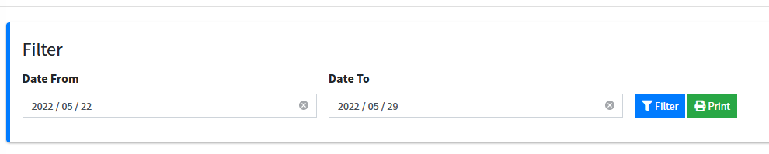

**Figure 18.**

Select a “**Date From**” and a “**Date To**” to generate a report of information recorded between two dates. Press on the “**Filter**” button to generate a report.

# Printing a Report

The user can use the “**Print**” feature shown on **Figure 18** to print the report after generating it. The report can be printed in different ways, including printing to PDF, OneNote, XPS Document, Fax, etc. **figure 19** shows the page you will see after pressing the “**Print**” button**.**

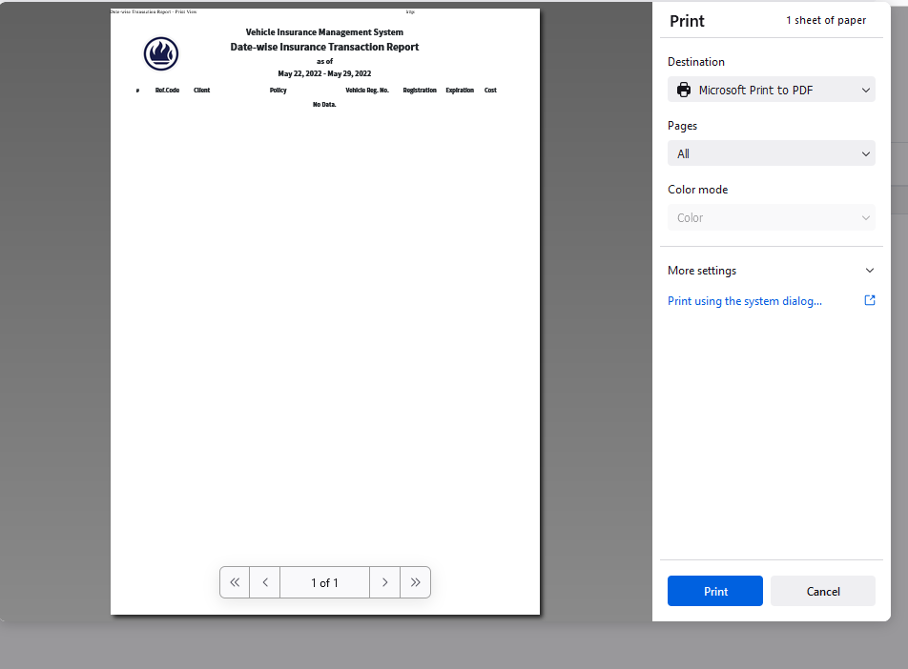

**Figure 19.**

Press the “**Print**” button to print the report or the “**Cancel**” to close the page.